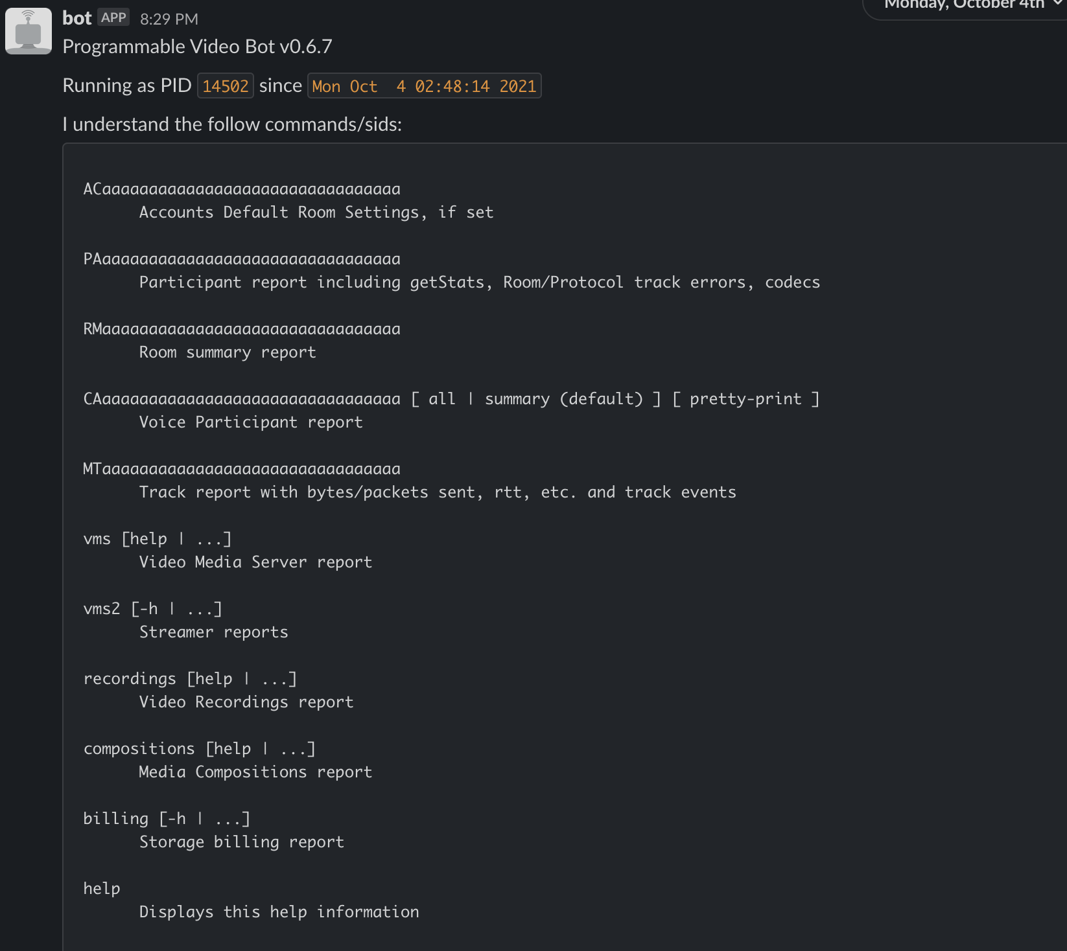

Account Info

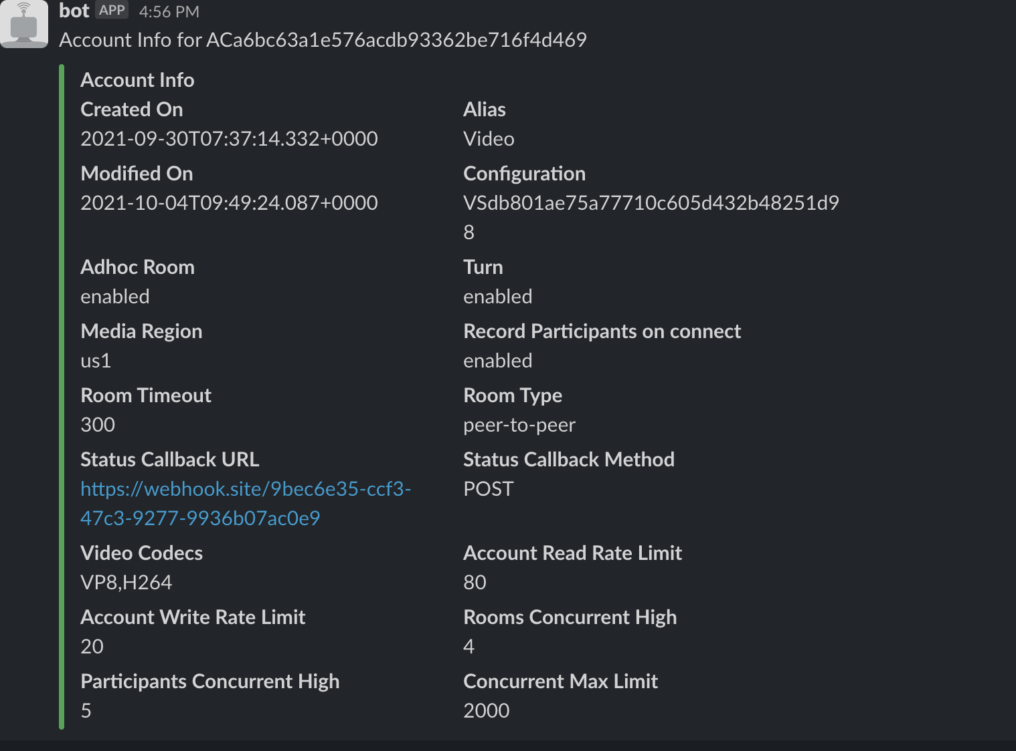

Recently created rooms

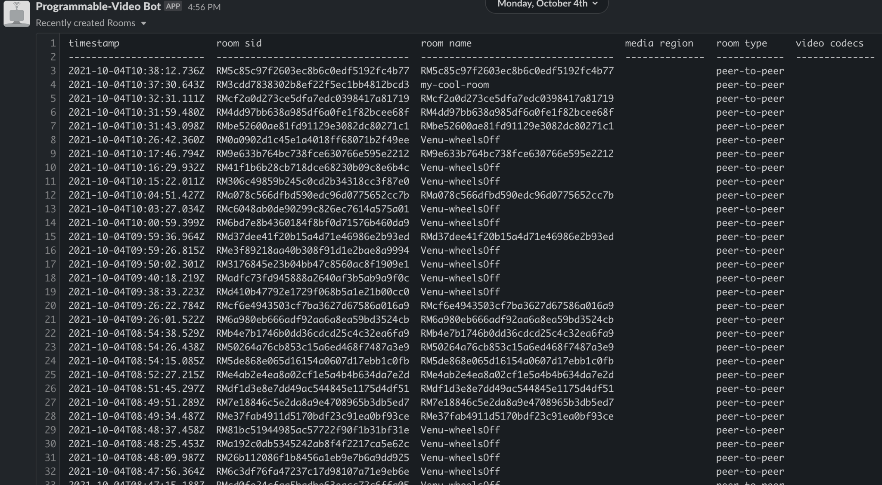

Participant Analysis

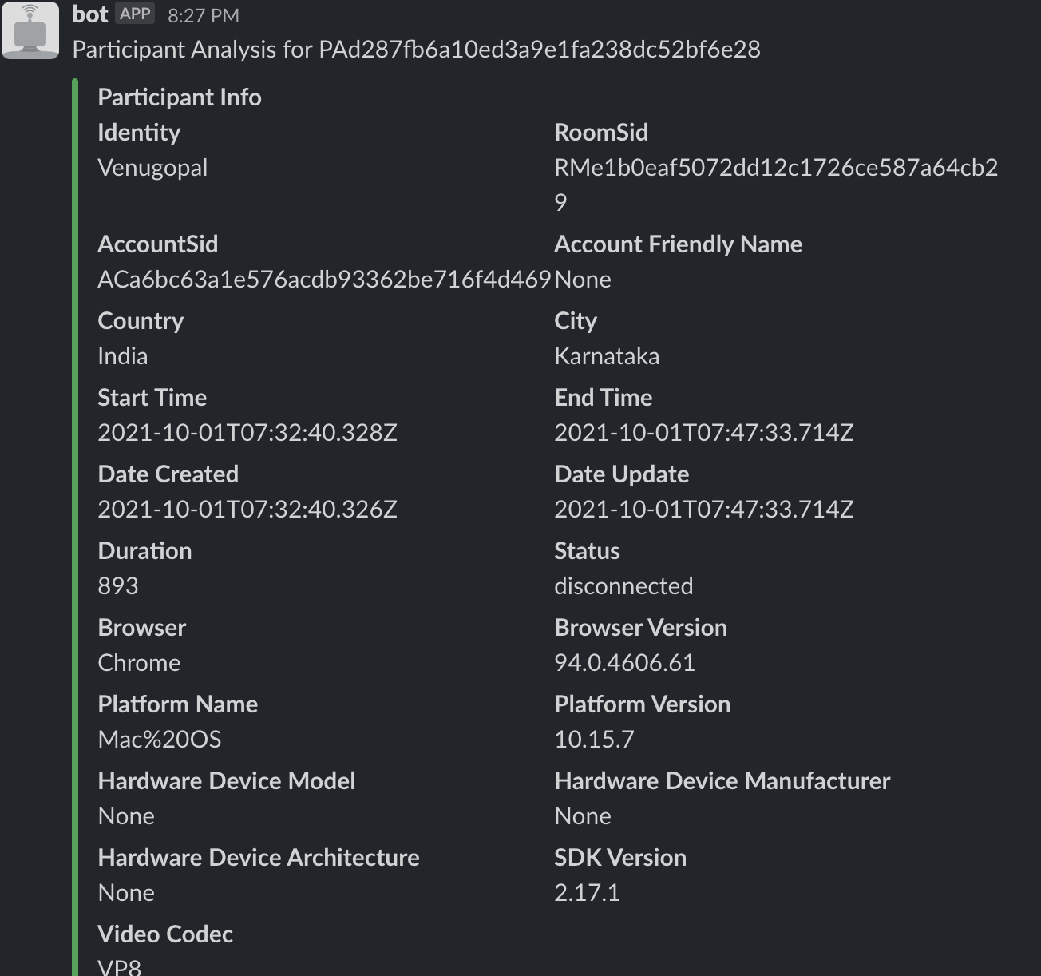

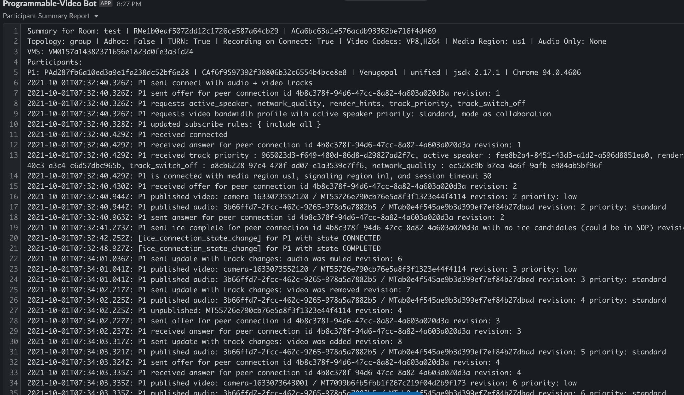

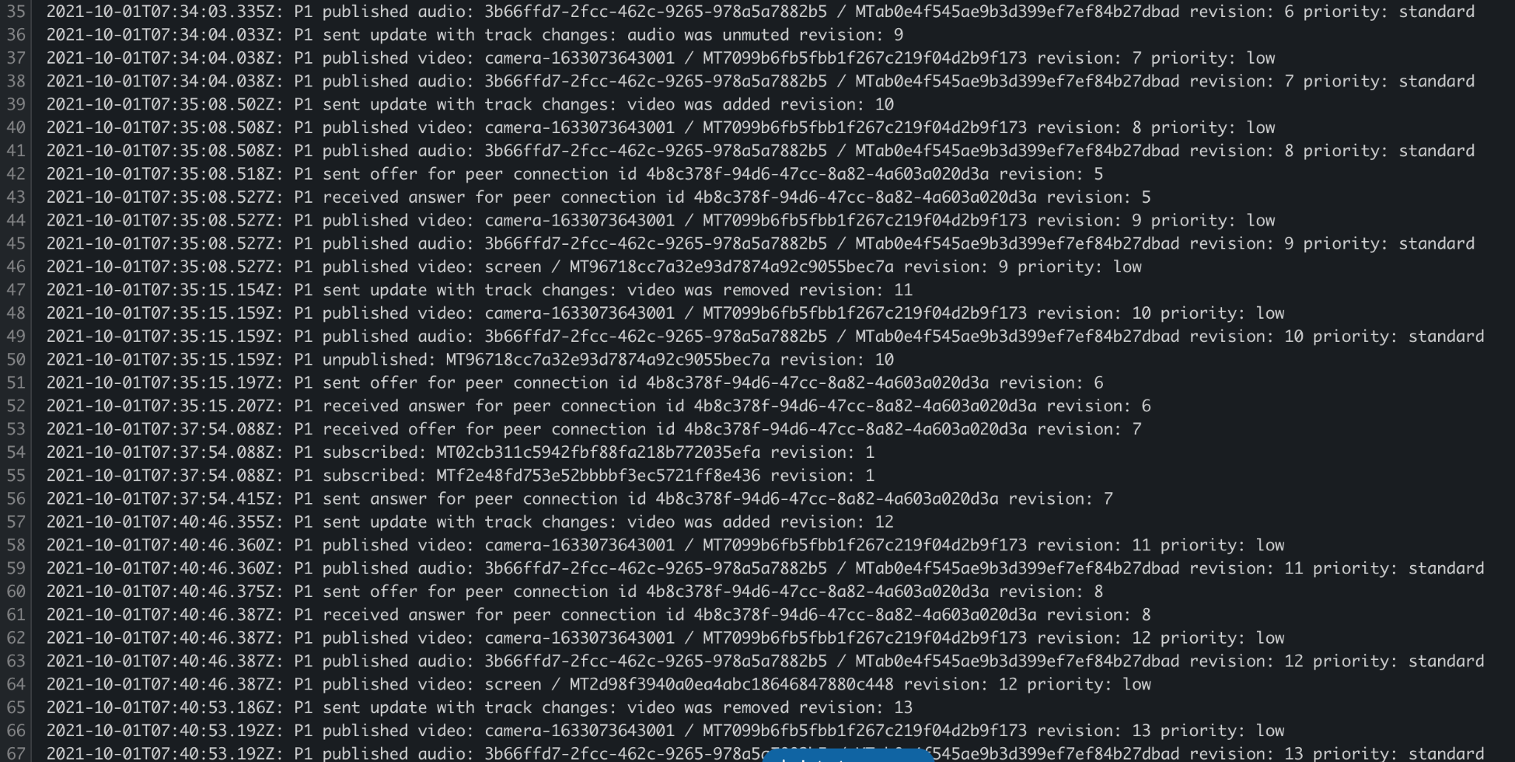

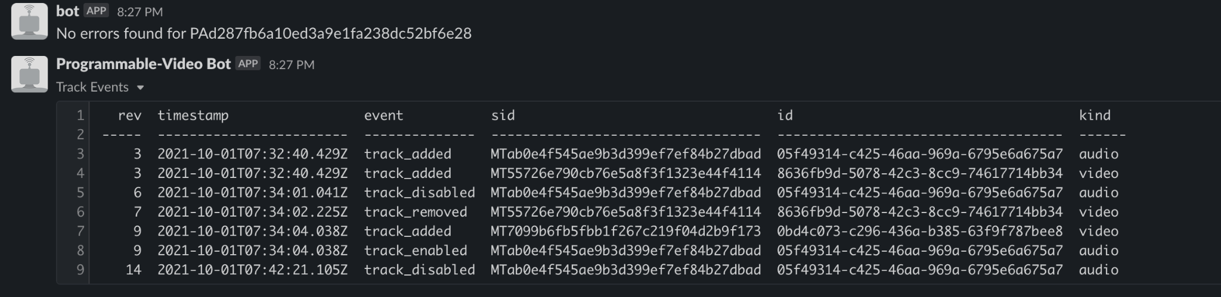

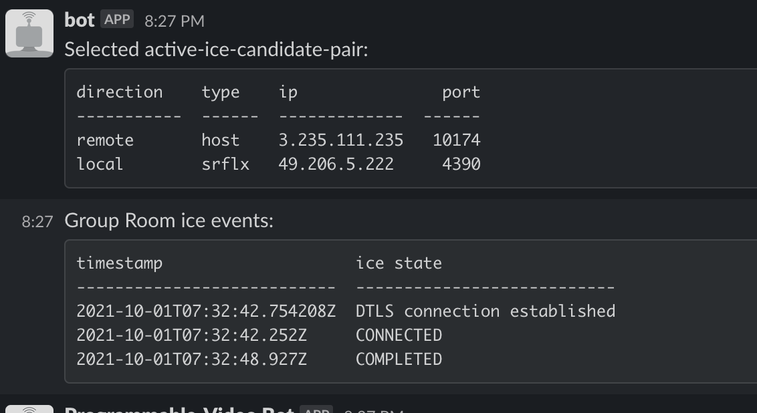

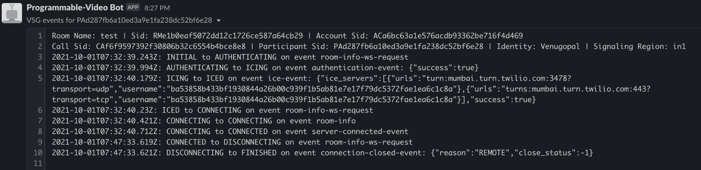

Room Analysis

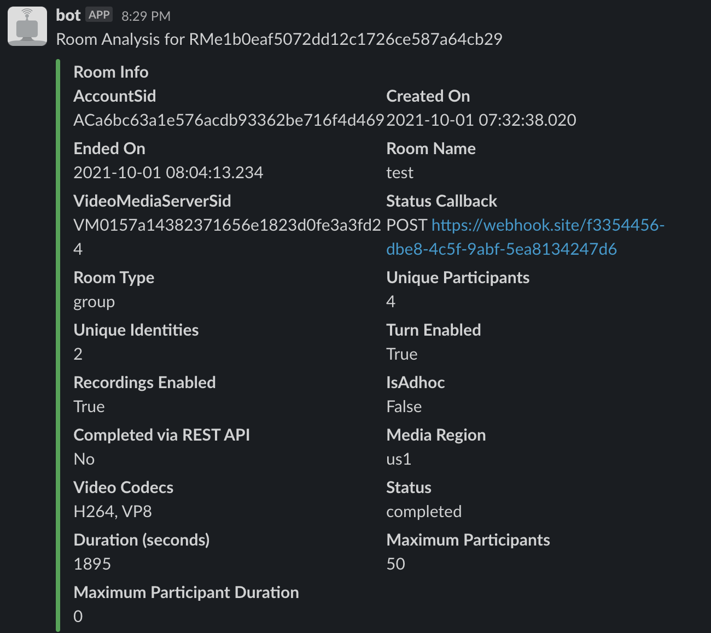

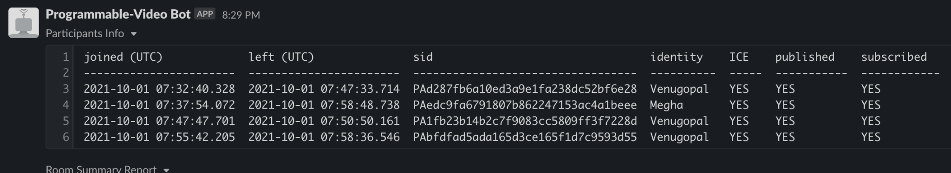

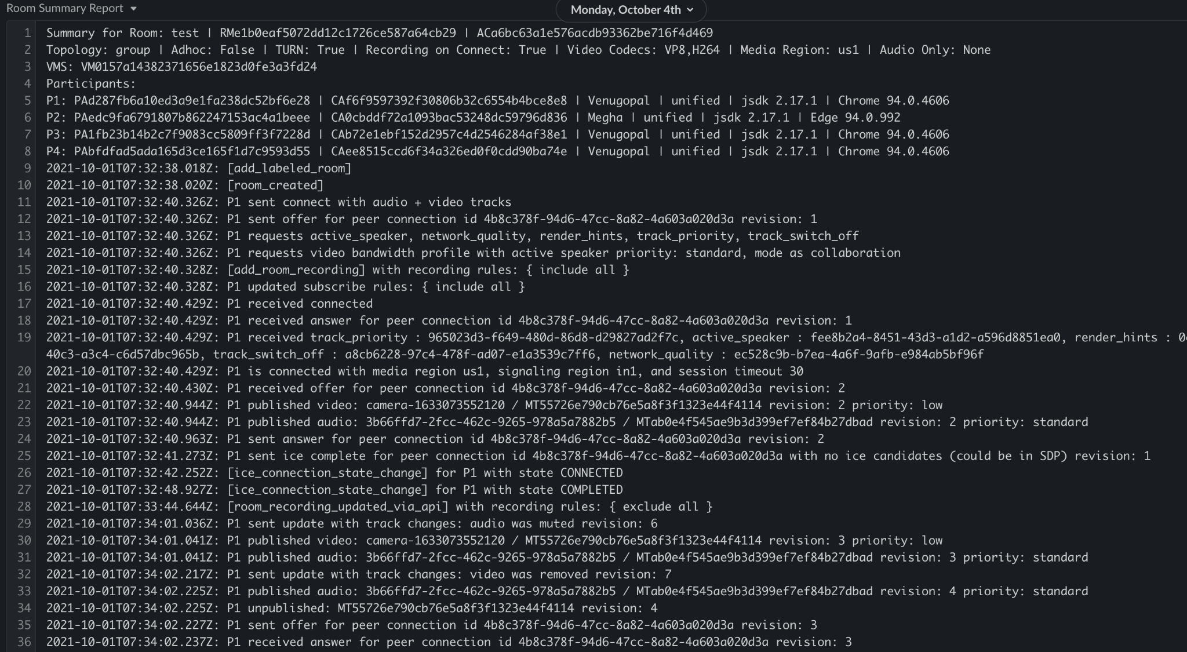

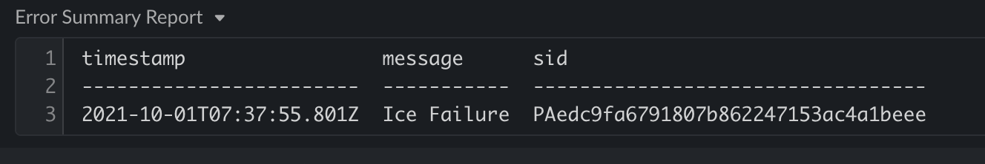

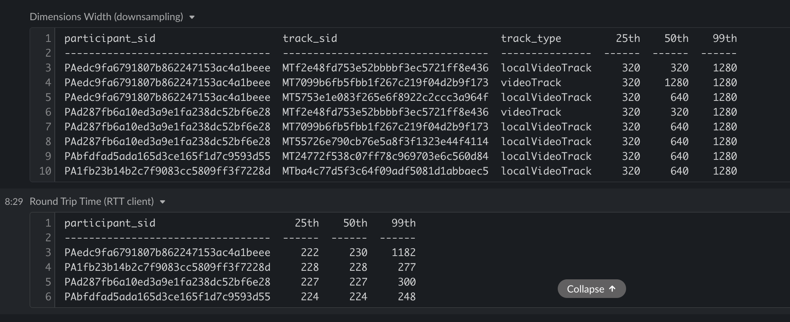

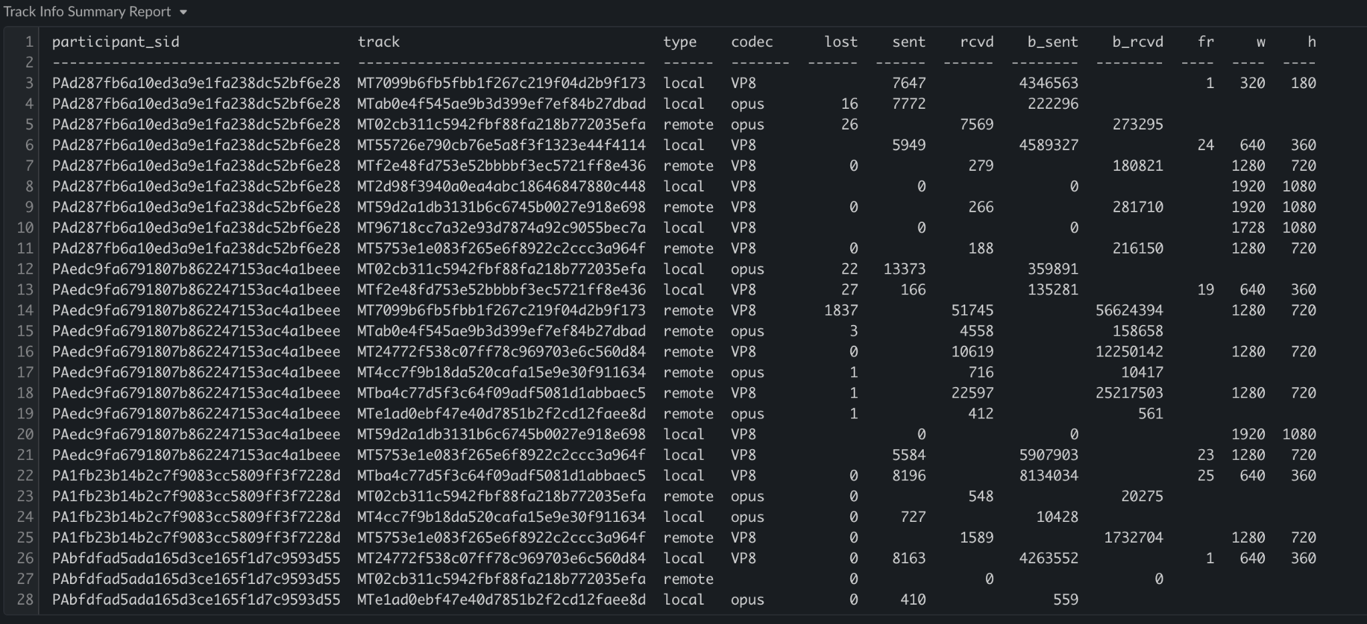

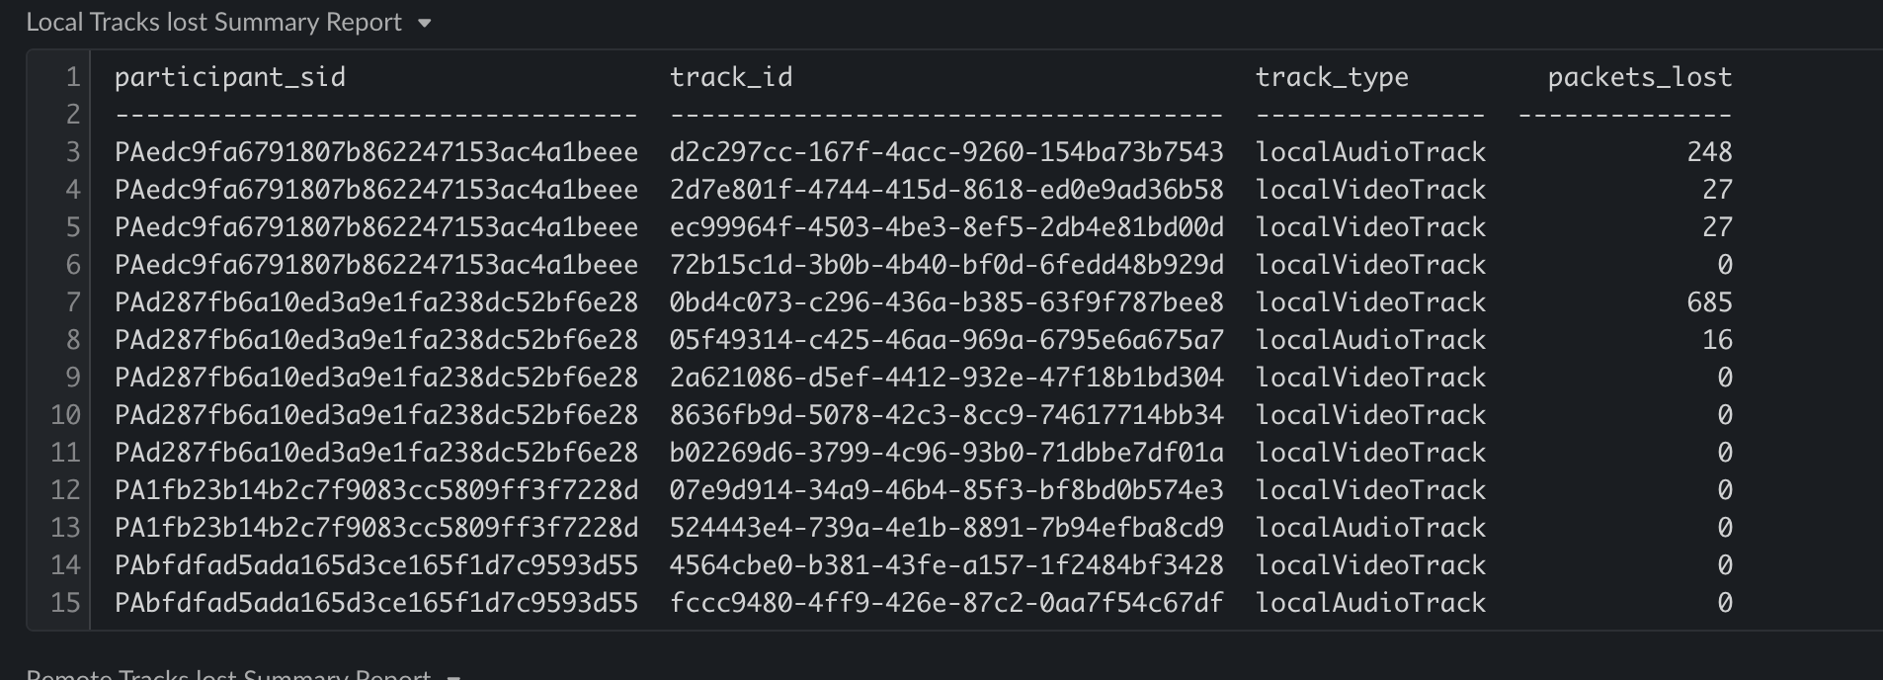

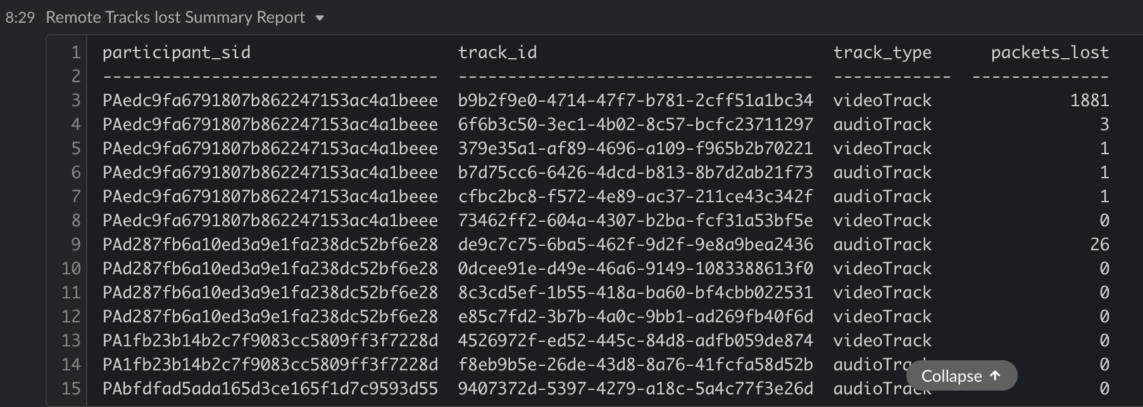

Track Analysis

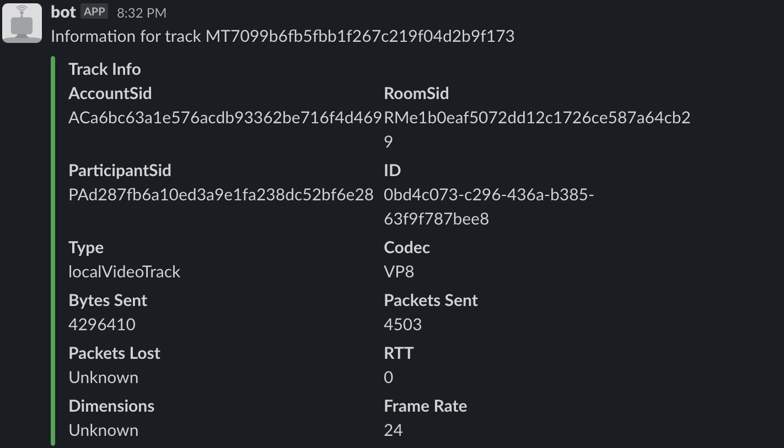

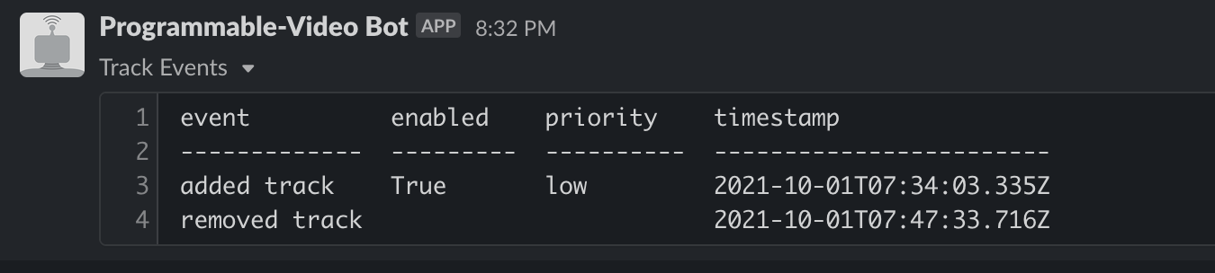

vms --room-sid RMe1b0eaf5072dd12c1726ce587a64cb29

-------------------

| Account: ACa6bc63a1e576acdb93362be716f4d469

| VMS: VM0157a14382371656e1823d0fe3a3fd24

| Host: HO032ca8d0ba73b422b9e4690068f9e6c2

| Region: us-east-1

-------------------

2021-10-01T07:32:40.338840Z - VMS process created

2021-10-01T08:05:13.744679Z - VMS process terminated

vms --recording-sid [RTb9013e052cea062a4bfcd9a0576524ce](https://www.twilio.com/console/video/logs/recordings/RTb9013e052cea062a4bfcd9a0576524ce)

No data available

vms2 rooms impact --sid RMe1b0eaf5072dd12c1726ce587a64cb29 recording

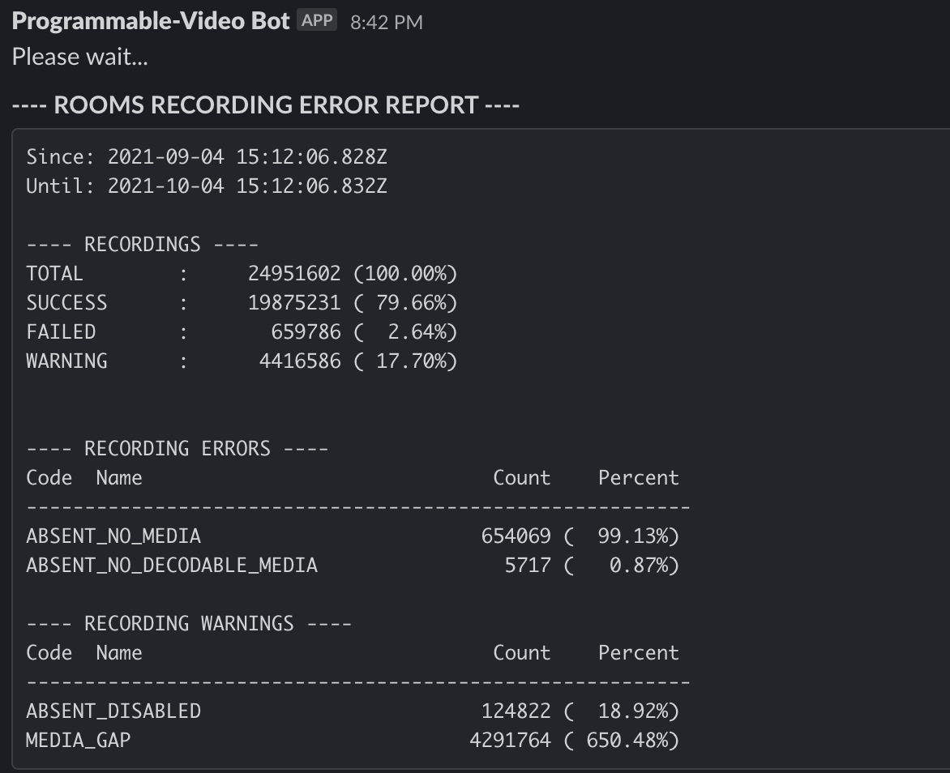

recordings --room-sid RMe1b0eaf5072dd12c1726ce587a64cb29

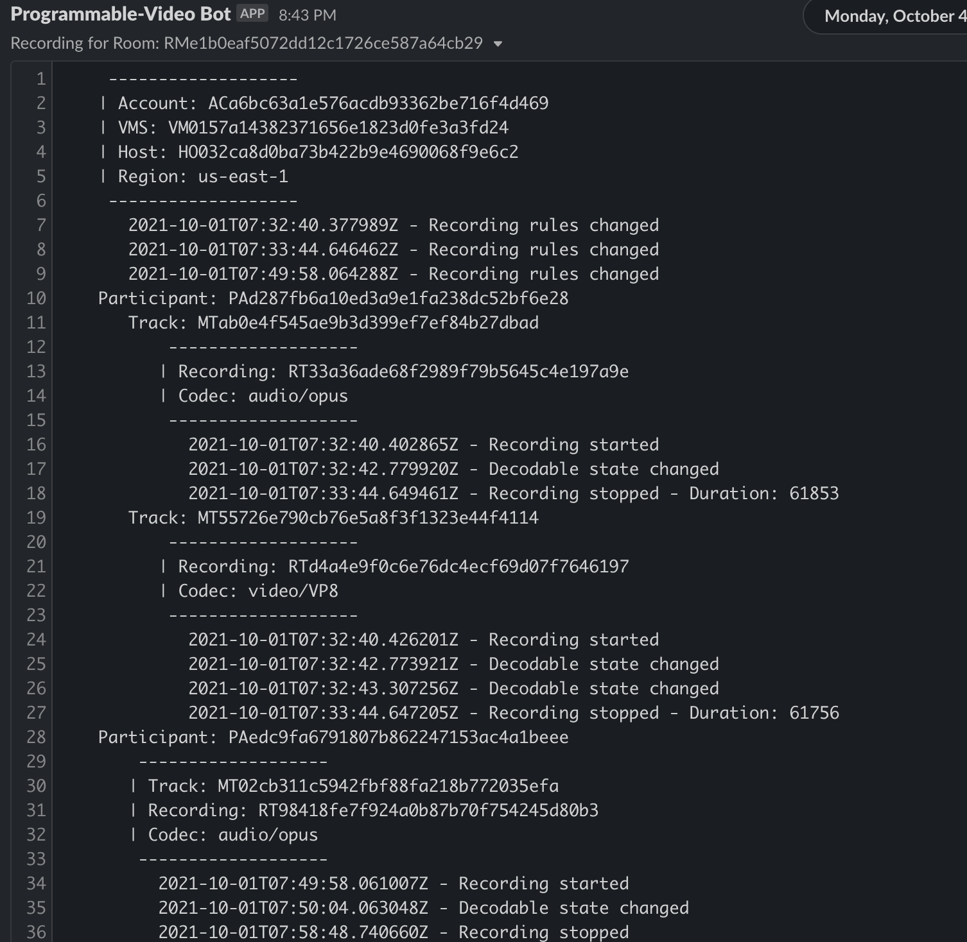

billing --account-sid ACa6bc63a1e576acdb93362be716f4d469 --since_until 2021-10-01 2021-10-04

billing --account-sid ACa6bc63a1e576acdb93362be716f4d469 --business-date 2021-10-01

Kibana Tasks

1. <https://kibana.us1.eak.twilio.com/video/goto/352d83d4611273536125d188995cbfe9>

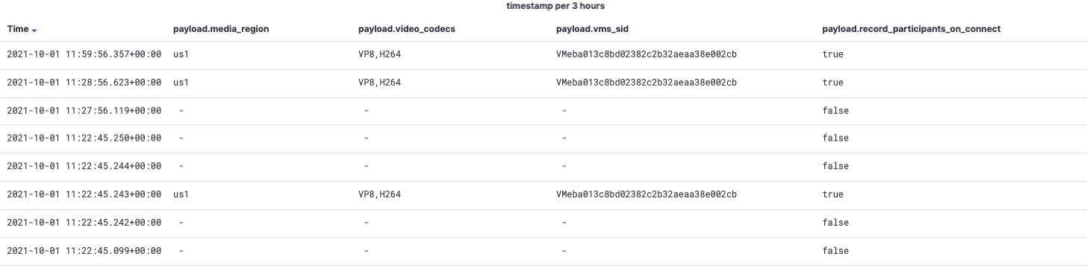

2. <https://kibana.us1.eak.twilio.com/video/goto/9ed673233cf931359d10474f3414b496>

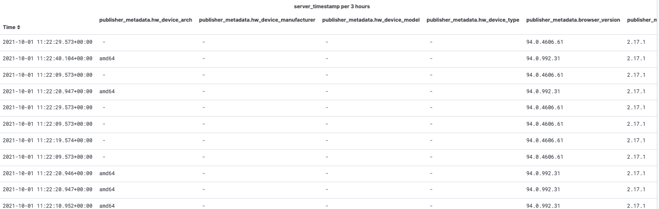

3. https://kibana.us1.eak.twilio.com/video/goto/1db5c9f80b63a8e6602fce4fd800919d

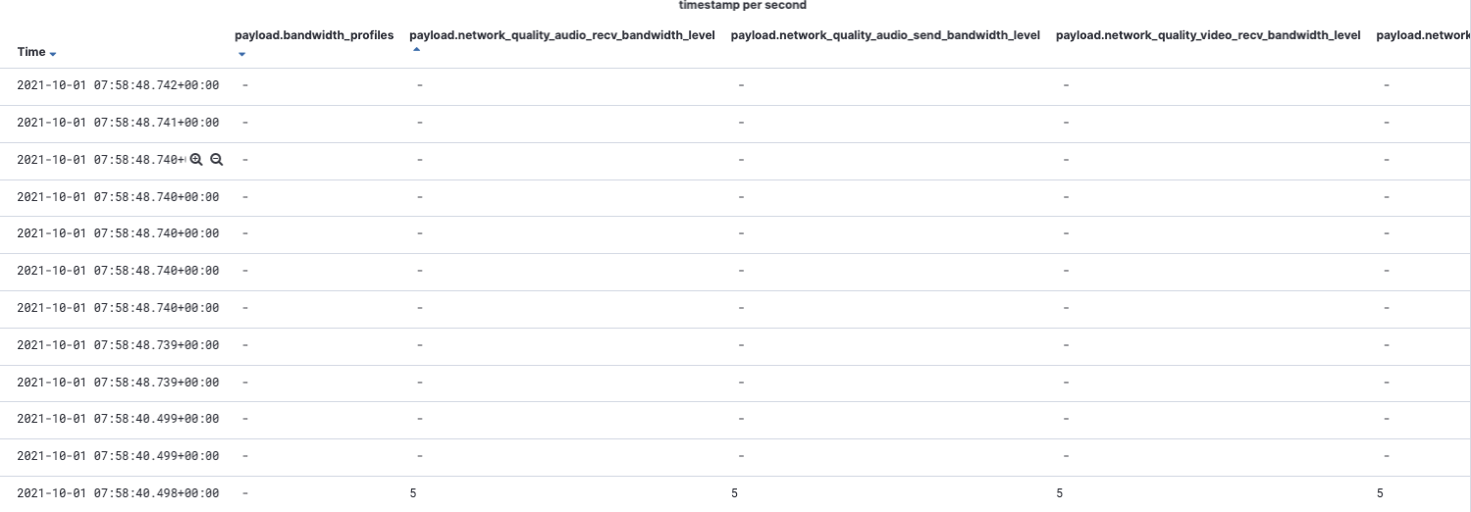

4. https://kibana.us1.eak.twilio.com/video/goto/b9ce8243094f895ec4da3876ac549987

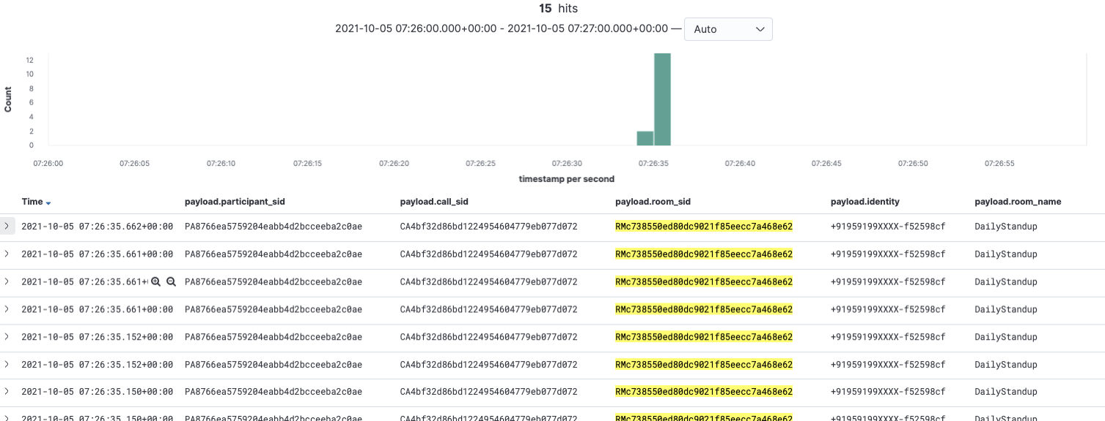

5. https://kibana.us1.eak.twilio.com/video/goto/c91c24740982c8ca09dddc58e422cf4d

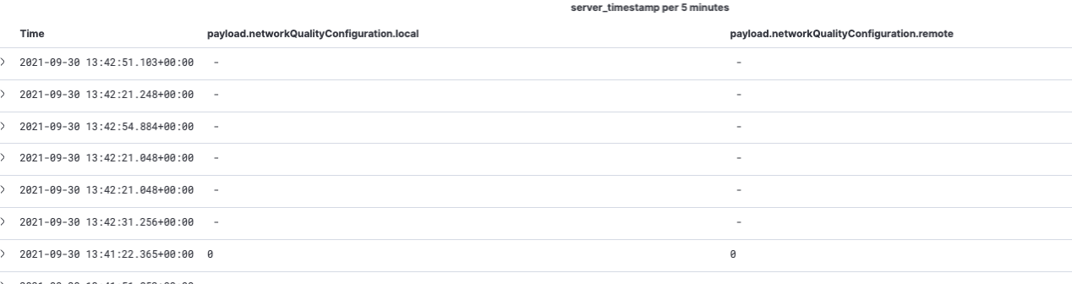

6. https://kibana.us1.eak.twilio.com/video/goto/476019d7ed4b6d396a563dab2f12c8ae

